STAT 252 R3

LAB 5

DONG, Boyuan

STAT 252 Lab5

1

(a)

The experimental unit: A process engineer with 27 firms

Random Selection of Units (Random sampling). The units in the sample are selected randomly from the population. The most basic form of random sampling is called a simple random sample (SRS).

Response variable is the thickness (in angstroms) of film coating, measurement unit is firm. The experiment is conducted by randomly selecting one of the temperature-pressure combinations and determining the thickness of the film coating after processing is completed.

The two factors are temperature and pressure

Levels of both factors are 1=low, 2=middle and 3=high

(b)

Experiment design: Randomized Experiment: A study in which treatment(s) are purposely imposed on the experimental units (individuals) to try and influence the response is called an experiment.

Inferences to the population (generalizations) can be drawn only if we have random selection from the population of interest.

Assumption:

A population inference implies that the results obtained from the sample can be generalized to an entire population.

Random sampling; Independent observation; Normal distribution; Equal standard deviations; No significant interaction between the temperature and pressure.

2

(a)

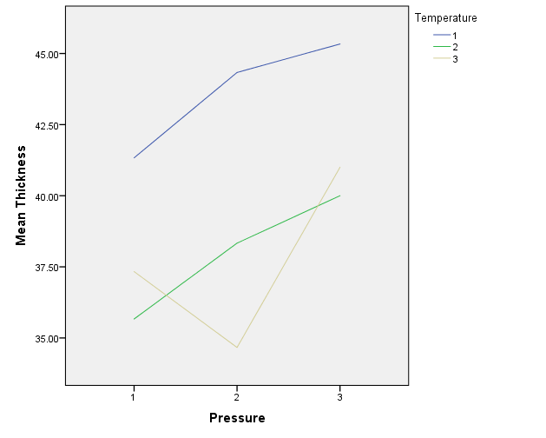

The line that temperature=1 is nearly parallel to the line that temperature=2. The effects for these two levels of the thickness seem to be additive. Thus we believe there is not interaction between these two categorical variables. There are two intersections between the line temperature=2 and line temperature=3. The line temperature=3 shows a decreasing effect from pressure 1 to pressure 2 and then shows an increasing effect from pressure 2 to 3. Since the line temperature=1 and temperature=2 are fairly parallel, we believe there will be two intersections between line temperature=1 and temperature=3.

The relationship between thickness and temperature is stronger. We see that the distances among three lines greater than the length of the perpendicular defined by the lines above.

The combination to produce the thinnest coatings: pressure=2(middle) and temperature =3(high)

The combination to produce the thickest coatings: pressure=3(high) and temperature=1(low)

(b)

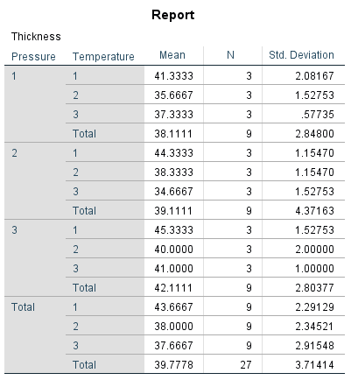

The highest mean thickness is 45.3333 when temperature=1 and pressure=3 as expected. The lowest thickness is 34.6667 when temperature=2 and pressure=3.

The mean thickness for temperature is temperature1- temperature3= 6; temperature1- temperature2= 5.6667; temperature2- temperature3= 0.3333, regardless of the pressure. Also, the mean thickness for pressure3-pressure1=4; pressure3-pressure2=3; pressure2-pressure1=1, regardless of the temperature. This confirms the stronger relationship between thickness and temperature.

Effect of temperature and pressure based on the table:

The effects for temperature1 and temperature2 of the thickness are additive.

The effect for temperature 2 of the thickness is decreasing from pressure 1 to 2 and increasing from pressure 2 to 3.

The effects for pressure1 and pressure3 of the thickness is decreasing from temperature 1 to temperature2 and increasing from temperature 2 to 3.

The effect for pressure2 of the thickness is decreasing.

In total, note the effect for temperature of the thickness is decreasing regardless the pressure, while the effect for pressure of the thickness is increasing regardless the temperature.

3

(a)

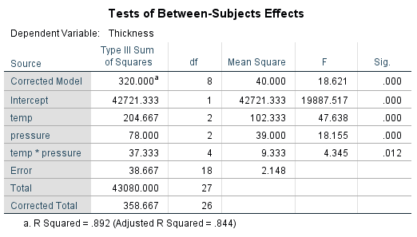

There are four sources of variation: the main effects of pressure and temperature, the interaction effect, and the error variation. Corresponding to these four sources, there are three null hypotheses that can be tested:

1. H0: No interaction pressure category and temperature category.

2. H0: No association between mean thickness and temperature.

3. H0: No association between mean thickness and pressure.

Since the presence of interaction can affect the tests for the main effects, we test the first hypothesis first, as the order may lead you to believe.

The total (corrected) DF is 26 which is one less than the number of thickness (observations) in the dataset. One degree of freedom is associated for each of the “Pressure” and “Temperature” variables since each has 2 levels (so the DF for each is 2-1 = 1). The model sum of squares is 320.000, the error sum of squares is 38.667, and the total sum of squares (corrected total) is 358.667. These values appear to be small, which is sensible since the dependent variables (thickness) ranges from

about 0.50 to 1.00. The p-value of the F-test for this model is about 0.000 so we have sufficient evidence at the 5% significance level that at least one of the associations hypothesized in the null hypothesis is significant.

The sum of squares for the Pressure factor is estimated to be 78.000. The p-value of the F-test is reported as 0.000, indicating convincing evidence of an effect of “Pressure” on the thickness. The sum of squares due to “Temperature” is 204.667, and is also significant based on its P-value of 0.000.

The p-value of the interaction term Pressure*Temperature is equal to 0.012

🡪0.01<P-value<0.05

🡪 Moderate evidence to against H0

🡪indicating a moderate level evidence of interaction between the two factors.

(b)

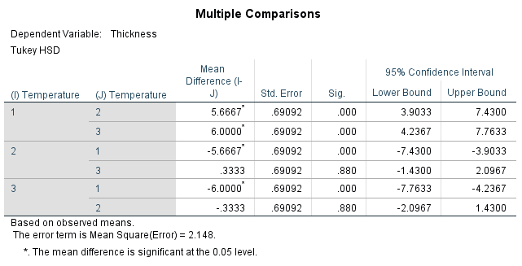

For temperature: Of the three comparisons, two reject the hypothesis of equality of the two means been compared and one does not. Equivalently, two confidence intervals does not contain zero and one contain zero. Thus Tukey HSD Procedure established difference between means in two cases and no difference in one case. In particular, there are significant differences between 1 and 2 level also 1 and 3 level. There is no significant difference in mean thickness 2 and 3 level. 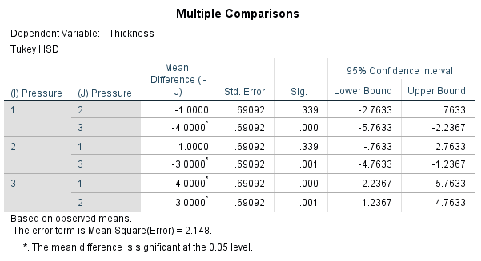

For pressure: Of the three comparisons, two reject the hypothesis of equality of the two means been compared and one does not. Equivalently, two confidence intervals does not contain zero and one contain zero. Thus Tukey HSD Procedure established difference between means in two cases and no difference in one case. In particular, there are significant differences between 1 and 3 level also 2 and 3 level. There is no significant difference in mean thickness 1 and 2 level.

4

(a)

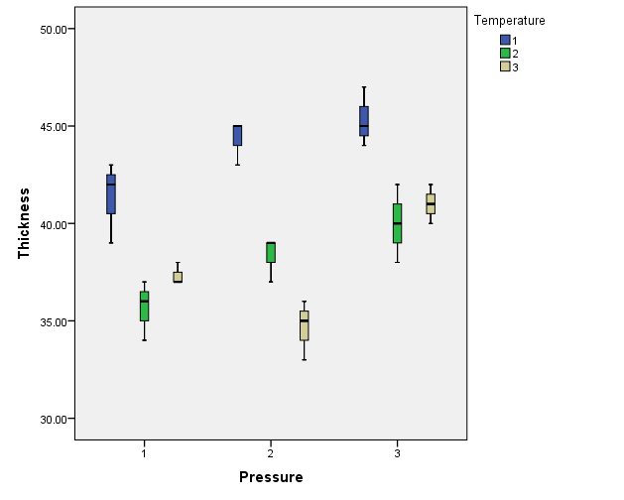

The nine boxplots identify the nine combinations of thickness (Pressure-Temperature: 1-1, 1-2, 1-3, 2-1, 2-2, 2-3, 3-1, 3-2, 3-3) the thickness is greater for high pressure regardless of temperature, the thickness is greater for low temperature regardless of pressure.

The combination to produce the thinnest coatings: pressure=2(middle) and temperature =3(high)

The combination to produce the thickest coatings: pressure=3(high) and temperature=1(low)

There are skewness for most of the boxplots above, right skewed (Pressure-Temperature: 3-1, 1-3), left skewed (Pressure-Temperature: 1-1, 1-2, 2-1, 2-2, 2-3). There are no outliers for all the boxplots.

The spreads have no sever difference, so there’s no strong evidence to suggest that the normality is seriously violated.

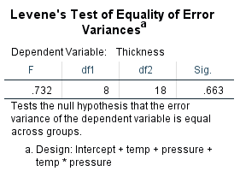

We have a P-value of 0.663, and therefore we have no sufficient evidence to say that the assumption of equal variances is violated.

(b)

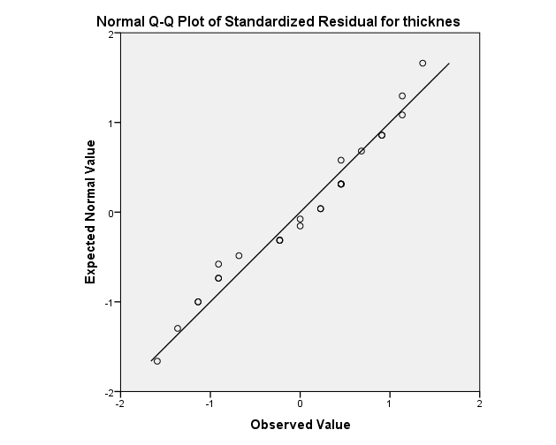

The points in the plot lie quite close to the straight line, thus there is no evidence that the assumption of normality is violated.